Chapter 14, Solution 80.

- 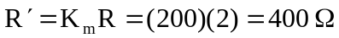

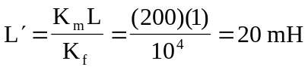
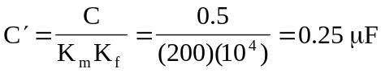
0.25 mF
I_{x}
400 W
20 mH
0.5 I_{x}
a
b
The new circuit is shown below.

- Insert a 1-A source at the terminals a-b.
1 A
1/(sC)
I_{x}
R
sL
0.5 I_{x}
a
b
V₁
V₂

At node 1,
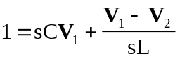 (1)

At node 2,
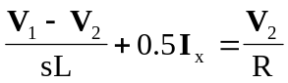
But, 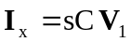.

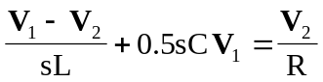 (2)

Solving (1) and (2),
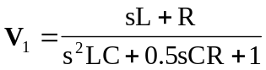

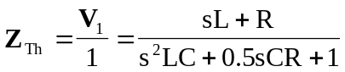

At 
